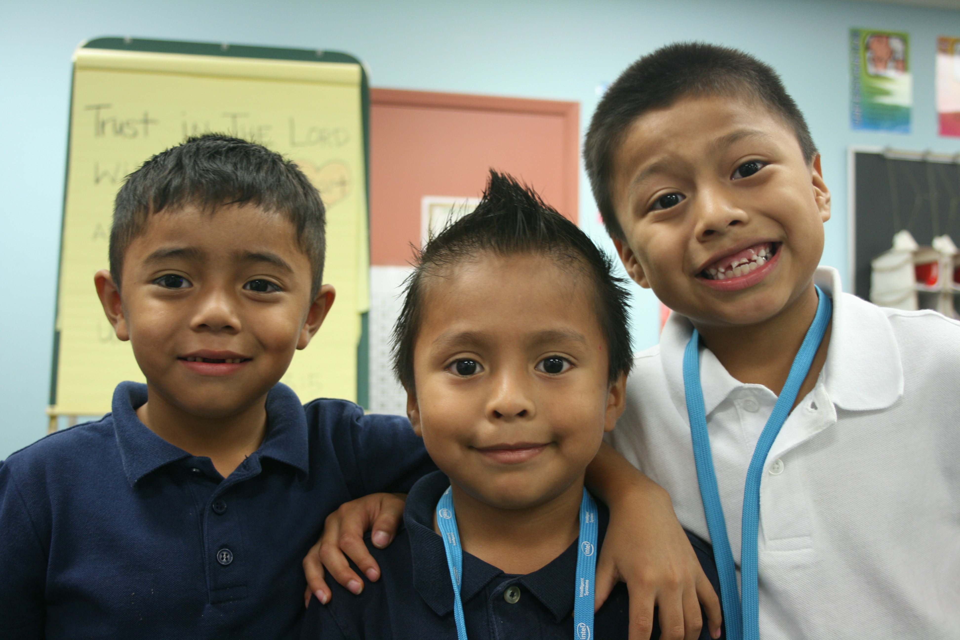

POSITION: VOLUNTEER MENTOR
LOCATION: Paiute Promise Neighborhood
HOURS: After-school program
AVAILABLE SHIFTS (can volunteer for one or more):
Monday 3-5:30pm, Tuesday 3-5:30pm, Wednesday 3-5:30pm, and Thursday 3-5:30pm

VOLUNTEER MENTOR
Do you love working with kids? Do you want to make a difference in the lives of kids? Do you want to be a part of a fun, lighthearted, Christian atmosphere where your skills and expertise are appreciated and used to help children reach their full academic potential?

ORGANIZATIONAL PROFILE:
MentorKids USA equips and empowers youth in underserved communities in the Phoenix area to become transformative leaders in their lives, their families and their communities, allowing those youth to reach their full potential. We offer support in academics, leadership development, spiritual development, and life skills.

In order to help kids, you also must work with the community around them. Promise Neighborhoods bring together youth, families, mentors, volunteers, churches, local businesses and other partners in underserved communities with the purpose of creating long-term solutions to the challenges facing our youth. At MentorKids USA, each child’s journey unfolds daily. Our programs help guide students along the path, providing the tools needed for a meaningful and grace-filled future.

WHY VOLUNTEER:
Research has proven that volunteering changes lives.
According to our own internal research, our MentorKids youth report an increased hope in the future, a more positive outlook on school/ education, increased civic engagement through service projects and spiritual growth. JOB DESCRIPTION:
MentorKids USA after school mentors are responsible for supervising, guiding and assist with learning experiences with a small group of children (3-5) ages 7 to 12, by following the lead of a certified teacher, helping the students to complete homework, read, be read, and other academic work. Also help to monitor students during snack time, dinner and play activities. The ultimate job of each mentor is to help children reach their full potential and to develop integrity, righteousness and leadership skills.

QUALIFICATIONS:
- Able to pass a criminal background screening
- High School diploma
- Experience working with elementary-age children (1st to 5th grades) preferred but not necessary.
- Being comfortable working in a Christian environment.
- Passion for the Promise Neighborhood Model, working collaboratively with children, their families, and other community partners to enhance the lives of the neighborhood residents.
- Commitment to Excellence

KNOWLEDGE AND SKILLS
- Demonstrated enthusiasm for teaching and developing young children.
- Excellent interpersonal skills with the ability to relate to young children, teachers and parents.
- Excellent verbal and written communication skills.

RESPONSIBILITIES
Embody and demonstrate a loving, positive character and ensure that students exhibit the same values.
Build rapport with students, parents, and families so they understand unambiguously that MentorKids USA values them and wants them to be part of something significant.
Promote a positive image within the community as an example for the children and families in all aspects of your life.

Interested? Please contact Rodrigo Silva, Paiute Promise Neighborhood Manager at rsilva@mentorkidsusa.org or 602-791-2749

OUR COMMITMENT TO VOLUNTEERS
Volunteers are an extremely valuable and important part of the MentorKids Paiute Promise Neighborhood. As such, here is our commitment to YOU. We will:
- Provide initial and ongoing volunteer training;
- Provide real-time support through qualified paid staff;
- Provide a safe and fun environment;
- Recognize your efforts through a Volunteer Appreciation Dinner;
- Seek your input and feedback on program design and your experience;
- Do all that we can to facilitate a successful, fun, and rewarding volunteer experience.

